**2.1 I can plan using suitable project management techniques**

Below is my plan for creating a website, using the scrum technique with Kanban.

Gantt chart

Before starting scrum I have prepared a Gantt chart:

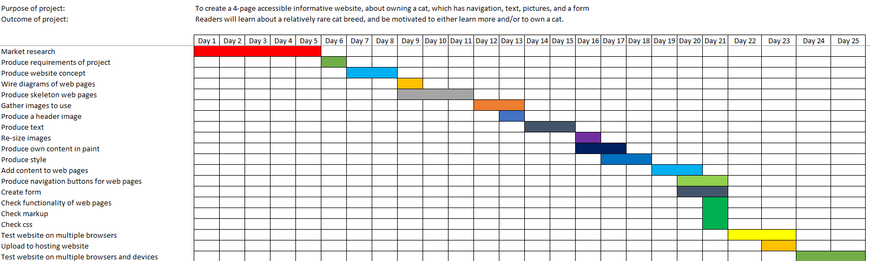

Product backlog

First, a list of all the tasks which need to be completed to achieve the product owner’s vision or goal are listed. This list can grow and develop throughout the process but tasks I envisage would need to be completed are:

* Market research
* Produce requirements of project
* Produce website concept
* Wire diagrams of web pages
* Produce skeleton web pages
* Gather images to use
* Produce a header image
* Produce text
* Re-size images
* Produce own content in paint
* Produce style
* Add content to web pages
* Produce navigation buttons for web pages
* Create form
* Check functionality of web pages
* Check markup
* Check css
* Test website on multiple browsers
* Upload to hosting website
* Test website on multiple browsers and devices

Once created, tasks would be given to teams to complete. Each team may list the tasks in the form of a Kanban list. In my case, in my case at the start of my project like this:

**To do**

* Produce requirements of project
* Produce website concept
* Wire diagrams of web pages
* Produce skeleton web pages
* Gather images to use
* Produce a header image
* Produce text
* Re-size images
* Produce own content in paint
* Produce style
* Add content to web pages
* Produce navigation buttons for web pages
* Create form
* Check functionality of web pages
* Check markup
* Check css
* Test website on multiple browsers
* Upload to hosting website
* Test website on multiple browsers and devices

**Being done**

* Market research

**Finished**

Sprints

Sprints (i.e. tasks or groups of tasks) would then be completed, one after the other, providing regular updates and versions of the website depending on my choices and the feedback provided.